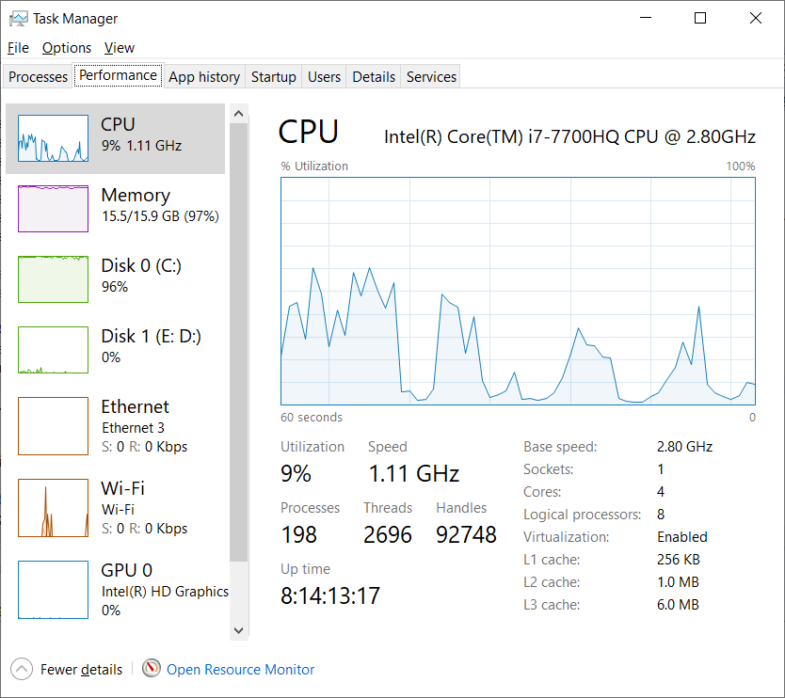

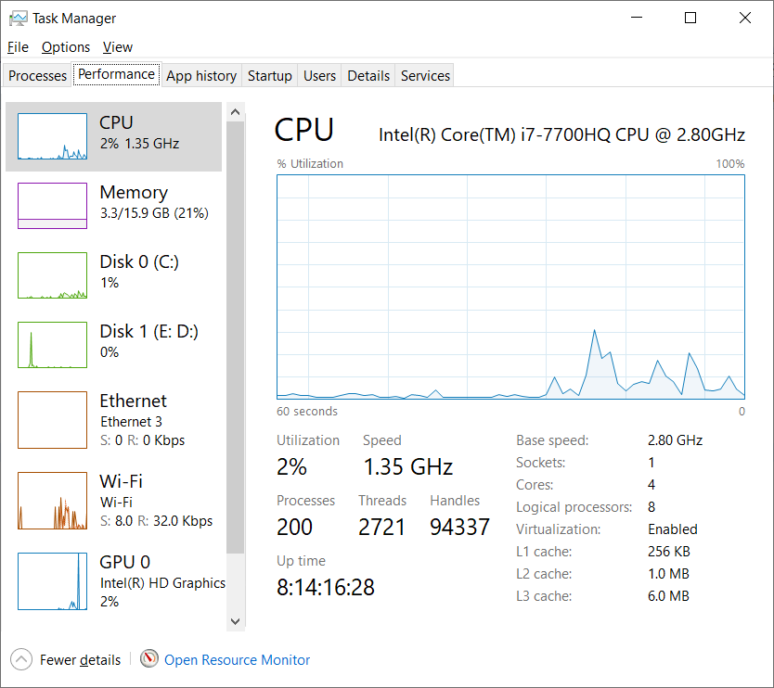

Array generated of size...2147488647

Value by Nitin : -2147388667

Time taken by Nitin : 138277.84 ms

Array generated of size...2157483647

Value by Nitin : -1957483667

Time taken by Nitin : 163214.23 ms

Array generated of size...2247483646

Value by Nitin : -247483686

Time taken by Nitin : 125574.33 ms

Array generated of size...2247483646

Value by Nitin : 42702189222

Time taken by Nitin : 287001.28 ms

Large Array generated of size...2247483646

Value by Nitin : 42702189205

Time taken by Nitin : 130661.08 ms